**Scrum Meeting Report**

**Sprint 1**

**● 21/04/2023, 20.08 – End**

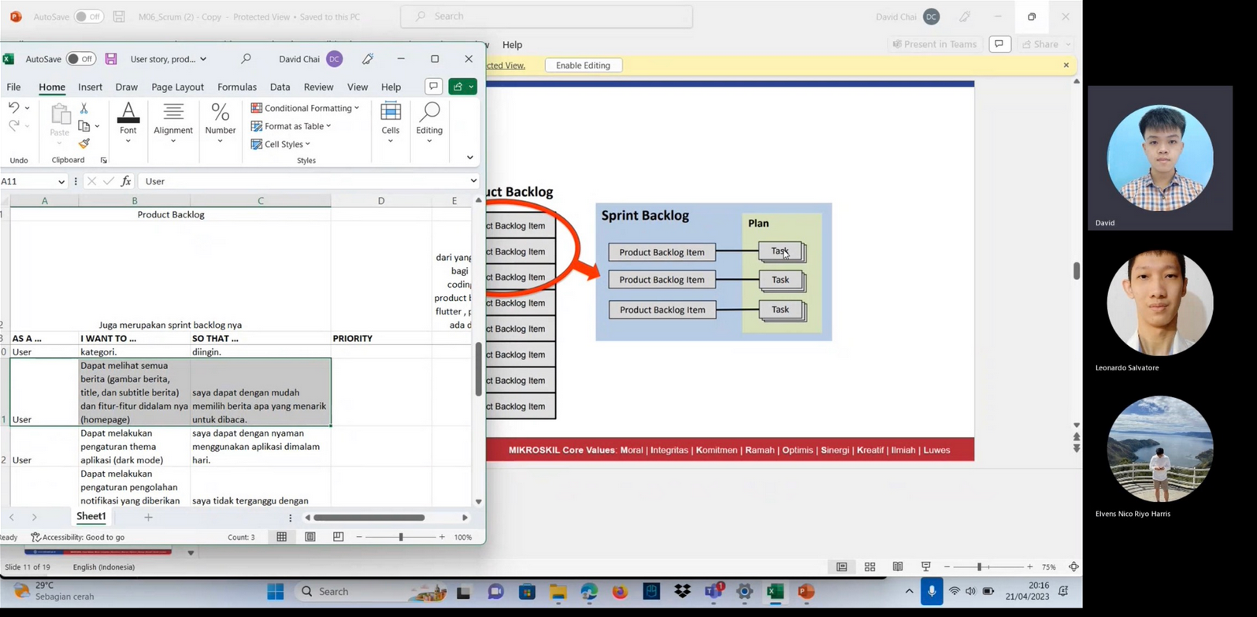

Link Meeting :

<https://mikroskilacid-my.sharepoint.com/:v:/g/personal/211110323_students_mikroskil_ac_id/EUEOcNe3sMBKronIUXpxPJwBaGs5nj8dyOc4LhxddVubOA?email=211111237%40students.mikroskil.ac.id>

**Sprint 2**

**● 27/04/2023 , 20.50 – End**

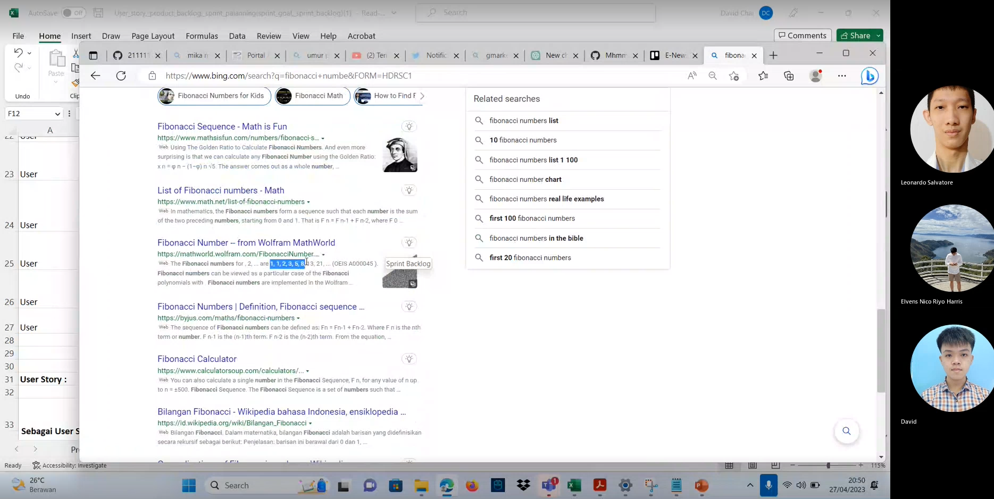

**Link Meeting :** <https://mikroskilacid-my.sharepoint.com/:v:/g/personal/211110323_students_mikroskil_ac_id/ETC6yxH4-_tLlggV8zaiMz0BcoOYVKRZYn3iOtdN4_m9rw?email=211111237%40students.mikroskil.ac.id>

**Sprint 3**

**● 29/04/2023 , 20.19 – End**

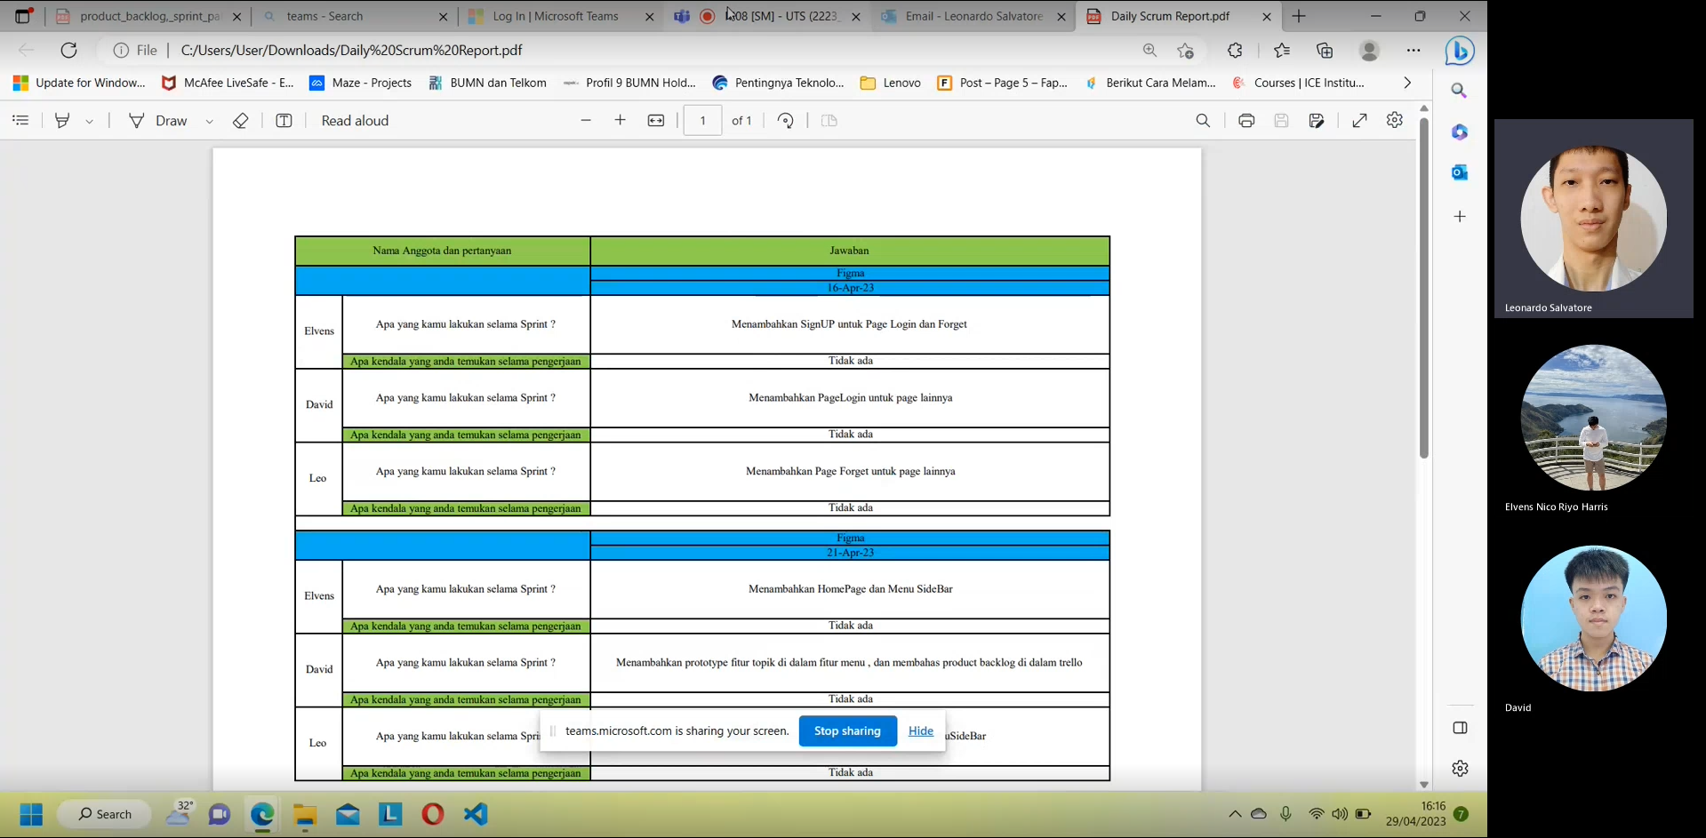

**Link Meeting :**

<https://mikroskilacid-my.sharepoint.com/:v:/g/personal/211110323_students_mikroskil_ac_id/EfWaWsSvpU1Bo6MF90DrVcUBrf7ucETC5Up2_lAbbUZORw?email=211110419%40students.mikroskil.ac.id>

**Sprint 4**

**● 4/05/2023 , 18.12– End** 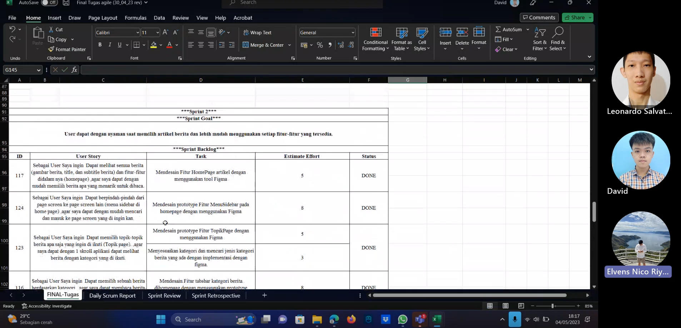

**Link Meeting :**

https://mikroskilacid-my.sharepoint.com/:v:/g/personal/211110419_students_mikroskil_ac_id/EUkxR380ZH1KpETYGbTOOSMBGjiXjvBIsk87L1BY8FokhA?email=211110323%40students.mikroskil.ac.id

**Sprint 5**

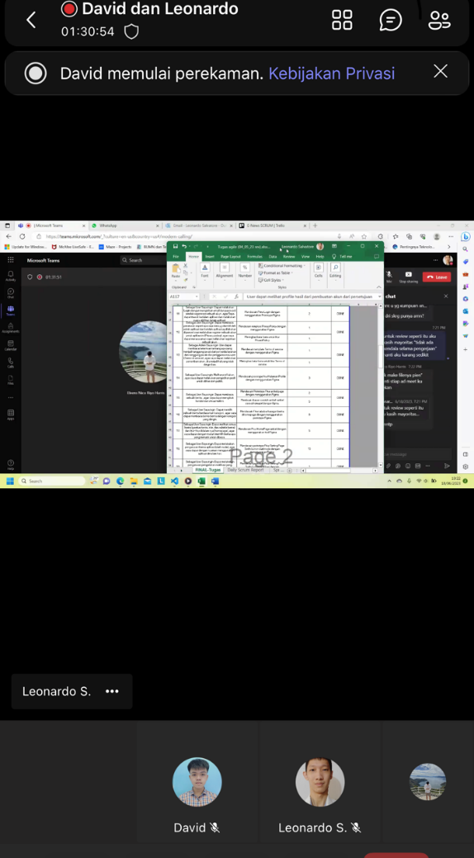**● 18 Juni 2023 , 17:25 – End**

**Link Meeting :** <https://mikroskilacid-my.sharepoint.com/:v:/g/personal/211110419_students_mikroskil_ac_id/EfJl7Qku849ForsNqT4lyDkB-zDzfqhM4jPAH8y9Y46MBQ>

**Sprint 6**

**● 21 Juni 2023 , 22:26 – End** 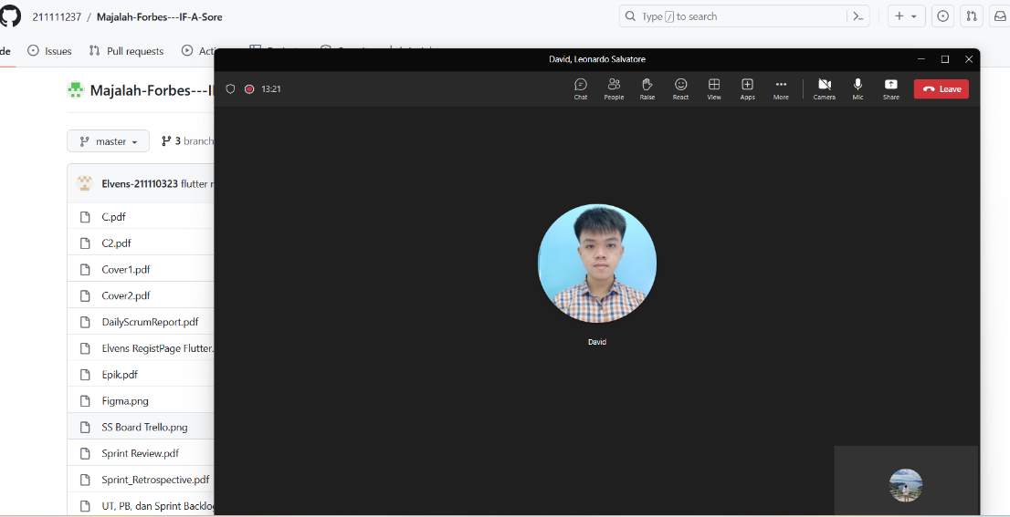

Link meeting :

<https://mikroskilacid-my.sharepoint.com/:v:/g/personal/211110419_students_mikroskil_ac_id/EW1xs6G05PdOnKItpcp3mVoBCiO9BCWNRw2SPfYRHEkbdg>

**Sprint 7**

**● 25 Juni 2023 , 19:26 – End**

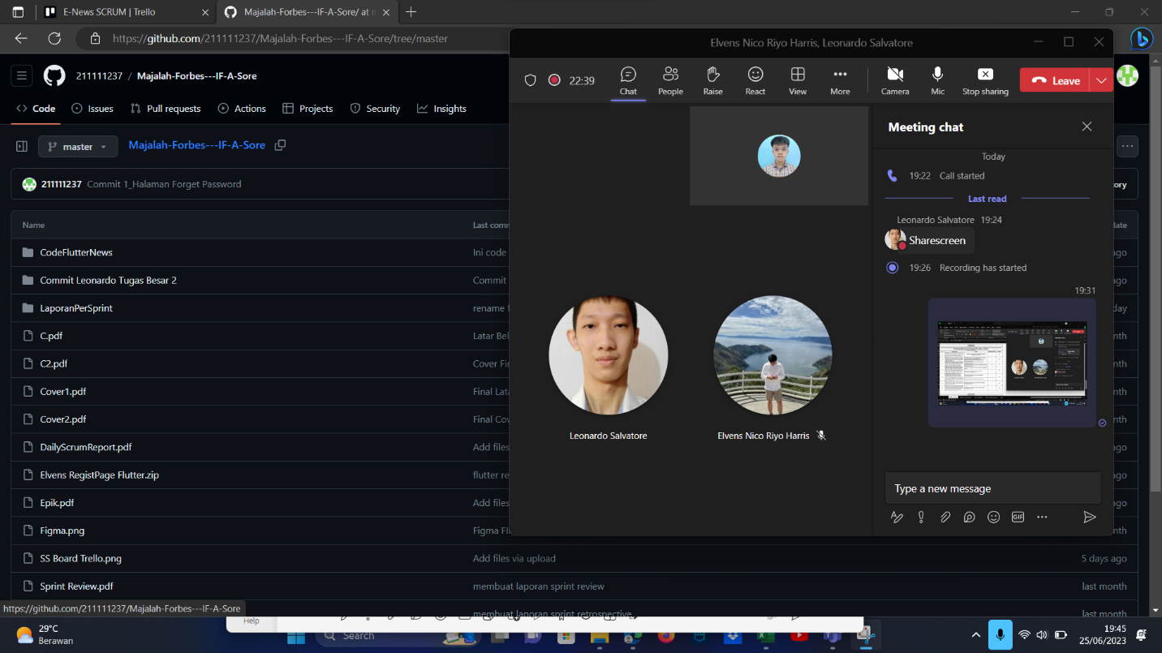

Link meeting :

https://mikroskilacid-my.sharepoint.com/:v:/g/personal/211110419_students_mikroskil_ac_id/ERq2IJL1vSdOl2Aym2lZFRkBubSrt3yAjhwmuuTzNIs4LQ

**Sprint 8**

**● 9 Juli 2023 , 19:45 – End**

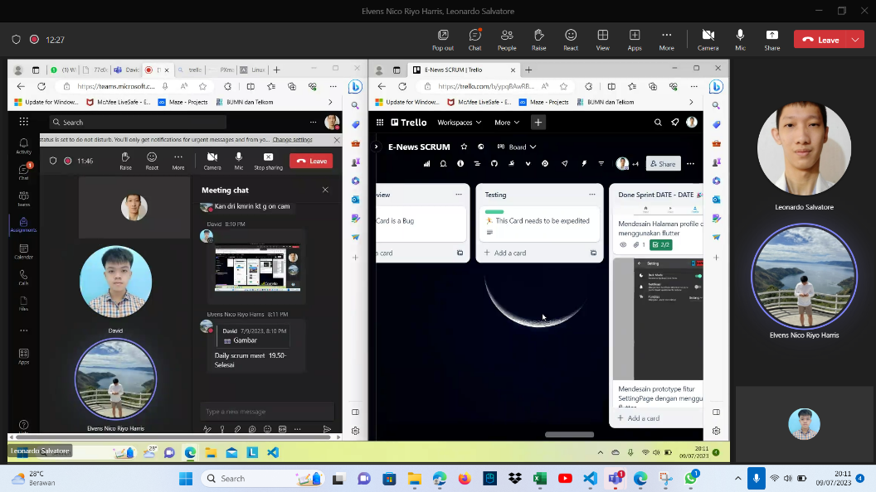 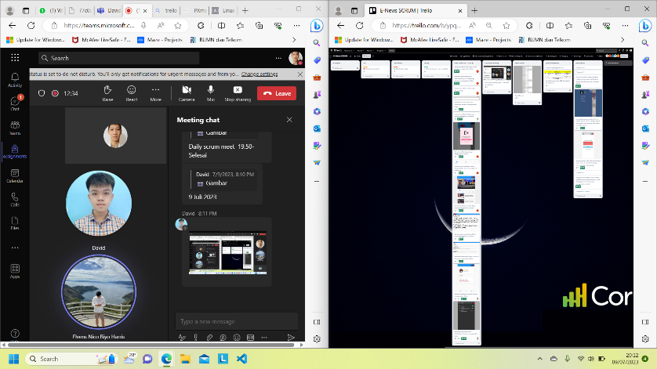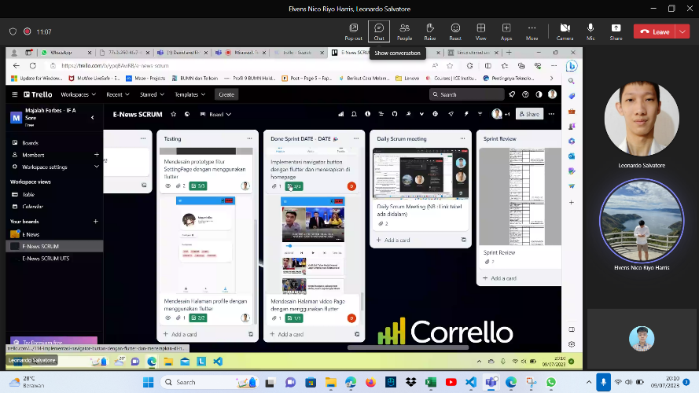

Link meeting :

https://mikroskilacid-my.sharepoint.com/:v:/g/personal/211110419_students_mikroskil_ac_id/EW-Y_wDw8ThCrlkIdlEP1dABMwx0WiWaBV_YOzzdLwS7tw